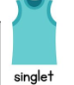
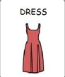
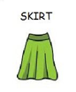
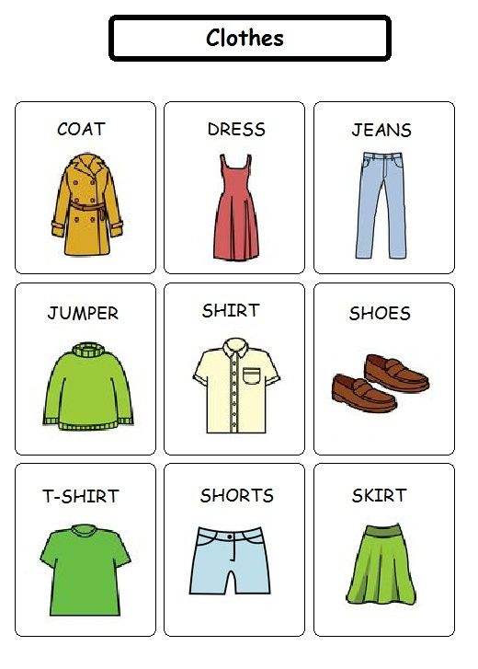
LIGHT CLOTHES IMAGE

